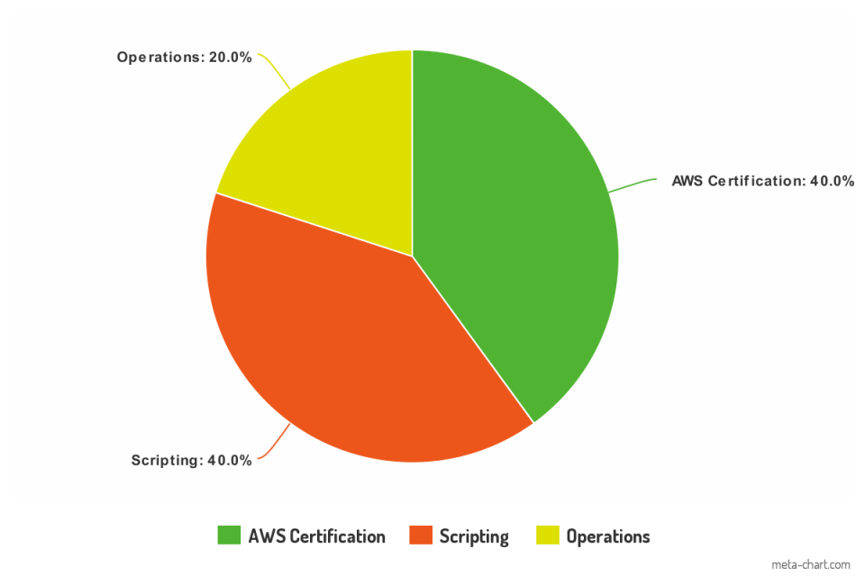Project; Dev. Ops Goals List

– Finn Armstrong-McAllister

# AWS Certification

|  |  |
| --- | --- |
| -AWS (Amazon Web Services) Certification would be a strong point to add to my CV when moving into the work force. | - I will be able to study for the labs required during time that I would be unable to visit the project room, meaning it’s practical to invest time into. |
| -As a beginner entering the group, having a structured learning route will allow me to create the skills I require moving forward. | - I intend to be ready for the exam before the end of the semester, meaning that I will have to plan out my study periods. |

# Scripting

|  |  |
| --- | --- |
| -To achieve this goal I will need to understand how scripts and VM’s interact with the programs that I use. | -I will assist my team mates with problems they have, creating scripts for my team mates whenever they’re needed. |
| -Scripting allows me to focus my time more accurately. As I am also taking the Operations Engineering paper, the two focuses will build one another up. | -I have had prior experience working with VM’s and PowerShell through previous papers, being Security and Linux, as well as personal study. |

# Operations

|  |  |
| --- | --- |
| -I’ve already performed a rundown of the D312 computers, asserting that everything was running. I found this activity to be very interesting, but it also pointed out a weakness that I have, in a lack of hardware knowledge. I would like to correct this. | -I intend to volunteer and actively pursue tasks related to PC repair. Ultimately, I want to able to comfortable identify the issues with a system and know exactly how to go about repairing it. |